Onyx Web Services
Mass Email Tracking System - METS



Table of Contents
1. Overview 4
1.1. Problem Space 4
1.2. Solution 5
2. Solution Design 6
2.1 Overview 6
2.2 Technical Processes 6

Overview

Problem Space
Onyx currently uses Accucast, a mass email vendor, to send email blasts to our prospects and customers. In order to send a blast email, a list is generated from List Management, placed into an XLS file and sent to the vendor. Accucast then sends the email blast out with various tracking mechanisms that allow for detailed reports to be given back to Onyx with click-through and email-viewed statistics. These services cost roughly $3000 a month, and can be more depending on how many emails are sent for programs running worldwide.
Third party mass email vendors offer rich reporting and tracking mechanisms, but have disadvantages that make an alternative compelling.
- Emails from outside vendors are more often identified as un-solicited email or spam. The following reasons apply:
  - Mass email vendors are identified by organizations, spam filters and ISPs to be the source of mass email, and can be blocked from the organization before it reaches the intended audience.
  - Spam filters and ISPs will notice a discrepancy between the sender of the email and the domain in which the email is being sent. In the case of Accucast emails, this is the information that is passed to our recipients
From: Onyx Software <sqlmail@onyx.com>
Reply-To: Onyx Software <2119.178230.717772373933@onyxsoftware.acc0.com>
Received From: atl-agent1.accelerator.accucast.com
You can see where the domain of the server in which the email is received does not match the domain from which the email says it’s from.
  - Various tracking mechanisms are added to the HTML code of the emails. Sophisticated Spam filters will look for IMG references that use parameters in the SRC tag. This snippet of code was taken from a recent Accucast email, and as you can see the img src has a parameter (anything after a ‘?’) and the entire image reference appears outside the body of the HTML email. This is a very easy tag for spam filters to identify.
</body>
</html>
<IMG HEIGHT=1 WIDTH=1 SRC="http://onyxsoftware.acc0.com/ct/click?q=52-LUConeJGzdIUZCiMfYbF9IMD">
- Accucast currently sends all email From: Onyx Software sqlmail@onyx.com with a reply address of 2119.-1.31323538373030@onyxsoftware.acc0.com. This solution lacks the ability to send an email directly from an individual such as Ben Kiker or Janice P. Anderson.
- A external system is in place for reports of success and opt-out information.
  - Data on the success of an email is outside of our main CRM system, so it is more complicated to track what types of people are viewing our email.
  - If a user decides to un-subscribe to a blast email campaign, Accucast notifies us of the opt out first, and then it is a manual process to mark individuals in OEP that no longer want to receive emails.

Solution
Web Services was recently addressed with the issue of sending an HTML email to a list of analysts from Patrick Angelel. Based on some of the above issues, we started looking for other options. Outlook was a possibility; however, Outlook adds many lines of HTML code that quickly corrupts the layout of the email. With no other solution available, we quickly wrote a web application that uses CDONTS objects to send mail via an SMTP server.
With the success of the newsletter, we started to look at solutions that would solve all of the issues with Accucast stated above. We created what we call METS, or Mass Email Tracking System.
METS is a web client that can take a list of email addresses, or OEP Individual IDs and send an HTML email. It has the ability to do real-time tracking of viewed emails within OEP; has integrated un-subscribe capabilities so that user’s OEP record is updated immediately when they opt-out; personalized merging of Name, Company and other fields from OEP data; an encrypted tracking system that allows for specific click-through analysis as well as personalization once the user accesses our site; and best of all, does not have all of the “Spam” earmarks that is inherent with third-party mass email companies.
We have already sent three METS blasts, and have seen positive results. Our first METS blast to customers resulted in adding $10,000 to our Q3 services revenue from education registrations. Another recent blast concerning a new Education Class recognized over $1800 in revenue in less than 24 hours from the sending of the email. We’ve also seen a tremendous increase in viewed emails. Over 25% of our recipients are viewing our media-rich emails, which is significantly higher than emails sent via Accucast. Most importantly, we are not charged per email.

Solution Design

Overview
Onyx METS is comprised of a web client and an HTTPHandler written on the .NET framework.
The web client is used to set up the HTML email for sending and has a myriad of fields to tailor the message for each campaign. The web client also contains the process for encrypting data into the email and sending it to each recipient.
The HTTPHandler was written on the .NET framework and sits on an externally resolved web server. When a recipient of a METS email reads, opens or downloads images on an HTML email, a call to the HTTPHandler is made and actions are performed in OEP that track what the user is doing. Each recipient has a unique encrypted code associated with their record in OEP. Actions can be captured and data manipulated in OEP when certain actions are performed either with the email or on our web site. This makes the technology not only good for sending emails, but a compelling tool for personalizing a user’s experience on the web.
The following subjects will be discussed in greater details in section 2.2.
- Sending a METS Email
- How it Works
- Why it Works
- System Requirements
- Next Steps

Technical Details

Sending a METS Email
Similar to Accucast, a List Management query is required to construct a list of the targeted recipients of the email blast. This query also has tests to ensure that users that have opted out of the mailings will not be included.
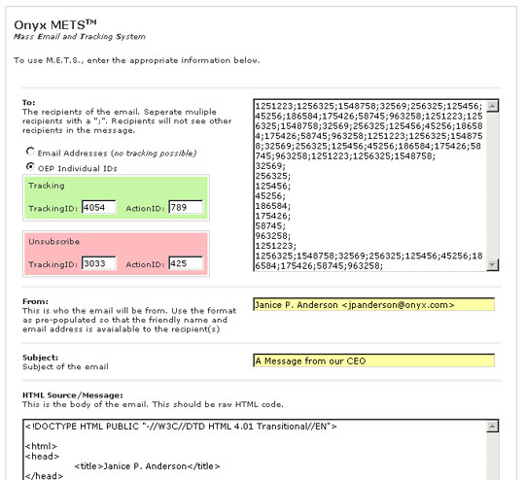
Figure 2.1

Working with the Client
- If you do not want to use OEP to track the email, you can simply place a ‘;’ delimited list of email addresses in the ‘To:’ text box and select the ‘Email Addresses’ radio box.
- If you want to track the email, a list of Individual Ids delimited by a ‘;’ is needed from the list management query. This could easily use an alternative construct, such as XML or a record set, directly from List Management in future revisions (see Next Steps below).
- When a user views a METS email, a tracking code/milestone is set immediately in OEP. There are some stipulations on when this action is launched (see How it Works), but it does happen in real time. The green tracking box holds the fields for entering a tracking id/milestone combination.
- By law, we have to offer the user the ability to “opt-out” of receiving future emails. We currently use a campaign model to designate a user as enrolling or becoming un-enrolled in an email list. The red unsubscribe area is where the appropriate unsubscribe tracking and milestone ids are entered for this particular list. The author of the HTML email does not need to worry about including text or a process for the opt-out functionality. METS will add the appropriate copy and functionality to the HTML automatically.
- You can send a METS email from any valid user of the Onyx domain.
- HTML Source is entered in the large text box. Personalized data can be merged into the HTML email with the use of different filters:
  - FFFFFFFFFF – will be replaced by the recipients First Name
  - LLLLLLLLLL – will be replaced by the recipients Last Name
  - CCCCCCCCCC – will be replaced by the recipients Company Name
- When the send button is pushed, the process will launch and a log of what is transpiring will appear on screen:
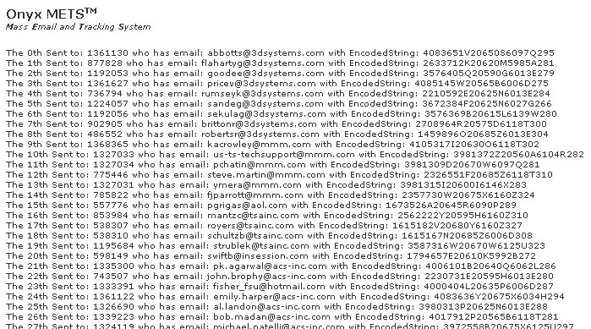
Figure 2.2
- This running log is used to track progress of who was sent an email. If something were to happen during the execution of METS, this could be used to start the process from the appropriate starting point.

How it Works

METS Processing
When the METS client page is submitted:
- A process starts and loops through the entire list of IDs that are delimited by ‘;’
- For each ID, a stored procedure is called that returns the individual’s email, first name, last name, company and two encrypted strings.
- The encrypted strings are important, and are the foundation for tracking and unsubscribing users.
  - One of the strings has the user’s individual ID, tracking ID and Milestone ID for tracking when they open the mail
  - The other string has the user’s individual ID, tracking ID and Milestone ID for opting out of an email blast
  - This is an example of an encrypted string: 3997953L20620N5985A269
- For each user:
  - The appropriate data is merged into the body of the HTML such as First Name, Last Name and Company.
  - An image reference inserted before the </body></html>. We want to make sure our image reference does not use a parameter, so the <img> tag for this image looks remarkably like this: <img src=http://www.onyx.com/timage/3997953L20620N5985A269.gif height=”10” width=”10”>.
  - An Opt-out note and link to unsubscribe are also inserted before the </body></html>.
  - A CDONTS Mail Object is created and used to send the email. The object uses the SMTP server residing on the machine in which the METS client is running.
This process can send over 200 emails a minute, and has not impacted our SMTP or Database services in any way.

Tracking and Un-subscribing
All email tracking software basically does the same thing – log an Image request. Accucast uses the aforementioned parameter method, which when the image is requested, the query string is parsed and logged in the web server. This process is called “Ad-Counting”, and some spam filters know to look for an image src with a parameter, and either block the message or warn the user that Ad-counting is happening.
We wanted to stay away from that method, knowing that we are going to get a slightly higher success rate if we do not appear to be Ad-counting. Our mechanism uses the name of the image as the encrypted string with the user’s ID, tracking and milestone rather than a parameter.
The image tag that is inserted before the end of the HTML looks something like this:

<img src=http://www.onyx.com/timage/12354586LARF78N5985A.gif height=”10” width=”10”>.

When the request goes to the /timage/ directory, it is actually launching an ASP.NET HTTPHandler. This handler intercepts the request, decrypts the string, and adds the appropriate campaign/milestone to the user’s record. It then binary writes a transparent image back to the client.
There are a few email clients that do not allow for the downloading of images by default for HTML emails, and for these users, we cannot track them. However, that would be the case regardless of which method we deployed.
Unsubscribing is similar, but for this, we can use a parameter. A lot of URLS require parameters, so Spam filters will not mark a message as spam if an HREF contains one. Our unsubscribe link would look something like this:

<a href=http://www.onyx.com/unsubscribe/default.asp?en=12354586LARF78N5985A>

The last bit of tracking we do with METS is change all HREFS in the email to one page which then redirects the user to the actual page they were requesting. We can then perform reports on the page to determine click-through rates and also follow the user from that page throughout the entire web site.

Reporting
- Since viewing an email sets a data point in OEP, we can create detailed reports on who is viewing our emails
- With our web technology, we can also track click-through analysis from a METS email and track the user’s progress through the site from the initial click in the email.
- Bad emails can be tracked via the inbox of the sending account, or with SMTP logs. Detailed reports and a process for marking bad-email still need to be created.

Why it Works
We feel there are two major reasons we are seeing more success with METS:
- The emails are personal correspondences from Onyx
- We have mitigated many of the tell-tale signs of spam email by carefully implementing technology and emails that originate from Onyx
To further clarify point number 2:
This is a sample log entry for sending emails with METs:
1. OutboundConnectionCommand SMTPSVC1 - EHLO - anaconda.issaquah.onyx.com
2. OutboundConnectionResponse SMTPSVC1 - 250-Postini+says+hello+back
3. OutboundConnectionCommand SMTPSVC1 - MAIL - FROM:<traininginfo@onyx.com>
4. OutboundConnectionResponse SMTPSVC1 - 250+Ok
You will notice that the EHLO (basically a hello to keep this simple) command (1) is sent to the recipient’s server with an Onyx domain machine. The Postini recipient server handshakes (2), and the conversation continues. The mail is then sent and is from an email address that matches the server domain that is sending the message (3). The last entry (4) simply confirms that the recipient received the email with no problems.
If the receiving organization had spam ware that blocked known mass-mailers, our email may not have gone past line 2 in the above sequence.
Also, since we do not use common Ad-Counting methods for tracking user views, we continue to ensure that the user receives an email directly from Onyx that is capable of tracking.

System Requirements
The following is needed in order to currently run METs:
- Internal web server running IIS/SMTP Services for client.
- METS web-client files (2 total)
- Encode and Decode Stored Procedures running on OED
- External web server running .NET framework and T-Image class Files (HTTPHandler)
- Optional: OED access from public web server to track users.
- Optional: Stored Procedure for actions in OED from T-Image execution

Next Steps
There are some immediate next steps that can be taken to integrate the client solution into OEP as well as develop some powerful marketing processes:
- The most obvious integration would be with List Management and adding a ‘bulk action’ to send the individual IDs to the METS client.
- Setting a campaign on email view was the most obvious action to trigger within OEP, however, creating message pops, sales opportunities and other actions are possibilities.
- With the encoding algorithm in METS, it’s possible that we no longer need web Forms to capture user information on our site. If the user goes to our site, we can immediately drop an identifiable cookie on their machine as well as actions in OEP. This will essentially let the user view our demo, download whitepapers…etc…without having to enter a passcode or fill out a lengthy form. Filling out forms is one of the largest deterrents when visiting a web site.
- Bad email reporting from SMTP logs still needs implemented.

